More than 450,000 Medicare beneficiaries accounts were billed for urinary catheters in 2023, up from about 50,000 in previous years, according to a new report produced by the Institute for Accountable Care and the National Association of Accountable Care Organizations.

The massive uptick in billing for catheters included $2 billion charged by seven high-volume suppliers, according to that analysis, potentially accounting for nearly one-fifth of all Medicare spending on medical supplies in 2023. Doctors, state insurance departments and health care groups around the country said the spike in claims for catheters that were never delivered suggested a far-reaching Medicare scam.
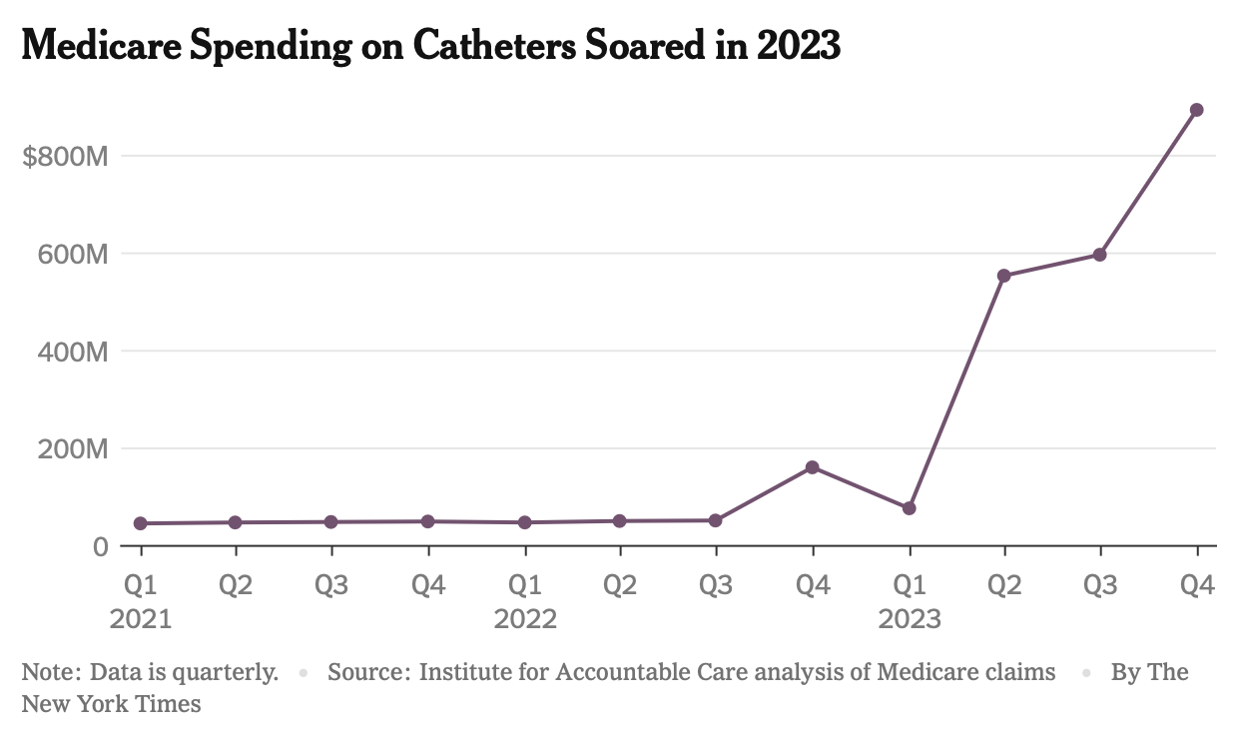

The vast majority of the suspicious claims identified by the new analysis came from seven companies, many of which have shared executives, according to public documents and the group’s report. Only one of the businesses had a working phone number, and it did not return a request for comment.
Access the full story: https://www.nytimes.com/2024/02/09/health/medicare-billing-scam-catheters.html

